Day 23 - 17th Aug 2026

Technical Assessment - Networking Fundamentals & Data Structures / Algorithms – Fill out form

Out of 28 Tasks … 14 tasks i.e 1 of each task are in session tasks and rest 2nd of each topic is a home task.

🏗 Brownfield vs. Greenfield
- What distinguishes a Brownfield application from a Greenfield one in terms of constraints and opportunities?
- Why might modernization of a Brownfield system be more complex than building a Greenfield solution?

💼 Business Drivers
- How do business drivers such as cost reduction, agility, and compliance influence migration decisions?
- Can modernization be justified purely on technical grounds without business drivers? Why or why not?

📊 Application Portfolio Assessment
- What is the purpose of conducting an application portfolio assessment before migration?
- How does inventorying applications and dependencies reduce risk during modernization?

🔍 Discovery & Mapping
- Why is mapping integration points critical when planning migration?
- How can overlooked dependencies derail a migration project?

⚖️ Technical Debt & Stack Evaluation
- How does technical debt impact modernization strategy selection?
- What role does evaluating runtime dependencies play in migration planning?

🗄 Database & Infrastructure
- What are the main risks in database migration, and how can they be mitigated?
- How does hosting infrastructure assessment influence cloud-readiness decision

🔐 Security & Compliance
- Why must security and compliance be reassessed during migration, even if the application was previously compliant?
- How does modernization affect risk posture?

🔄 Migration Strategies (6 R’s)
- How do the 6 R’s of migration provide a framework for decision-making?
- In what scenario would refactoring be preferable to rehosting?

📈 Cost & Effort Analysis
- How does TCO (Total Cost of Ownership) differ from upfront migration cost?
- Why is effort, complexity, and risk scoring essential for prioritization?

🗂 Prioritization & Planning
- What factors determine wave planning for application migration?
- How does prioritization balance business urgency with technical feasibility?

🏛 Target-State Architecture & Patterns
- How does defining a target-state architecture guide modernization choices?
- Compare the Strangler Fig pattern with the Anti-Corruption Layer in terms of risk mitigation.

📦 Containerization & Cloud-Readiness
- What are the key indicators that an application is cloud-ready?
- How does containerization support modernization goals?

📏 Success Metrics & Roadmap
- Why are KPIs critical in measuring migration success?
- How does a migration roadmap align technical execution with business case justification?

🛠 Tools & Documentation
- What role do assessment tools play in reducing subjectivity during migration planning?
- Why is documenting findings essential for stakeholder buy-in?

—---------------------------------------------------------------------------------------
10.25 to 10.45 – complete tasks ..
Till 11 am (10.45 to 11 break)
Redis:
Task 1:
What is Redis used for ? why ?
11.34 to 11.36
Task 2.:

Can you explain the architecture of Redis with a diagram?
11.37 to 11.42
Task 3:

What are the advantages of redis and also disadvantages?
11.43 to 11.46

Task 4:
Install docker in your system
Steps
- Download from https://www.docker.com/products/docker-desktop
- Run installer
- Enable hyper-v
- Restart the system
- Check docker version in cmd
  - docker –version
- Done installed docker ..

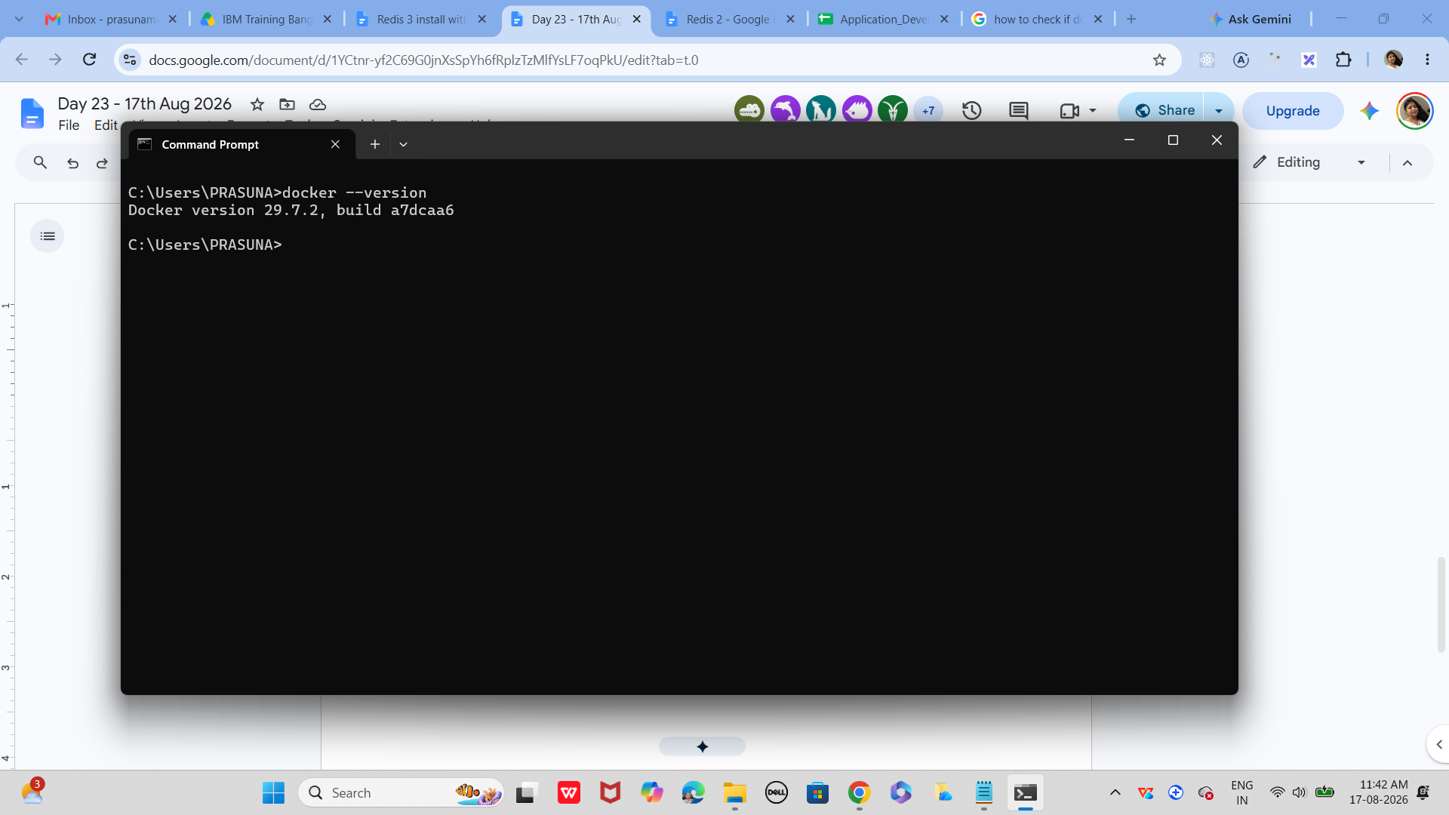

Task 5:
Open docker from the start menu
Now check
Docker version
It should show
Client and server version information like the below ss

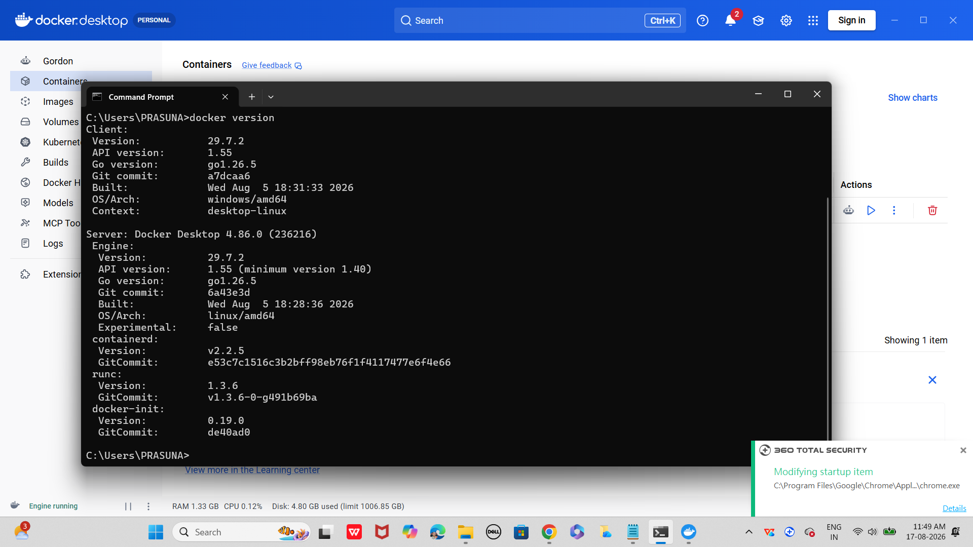

Use command to pull image
docker pull redis

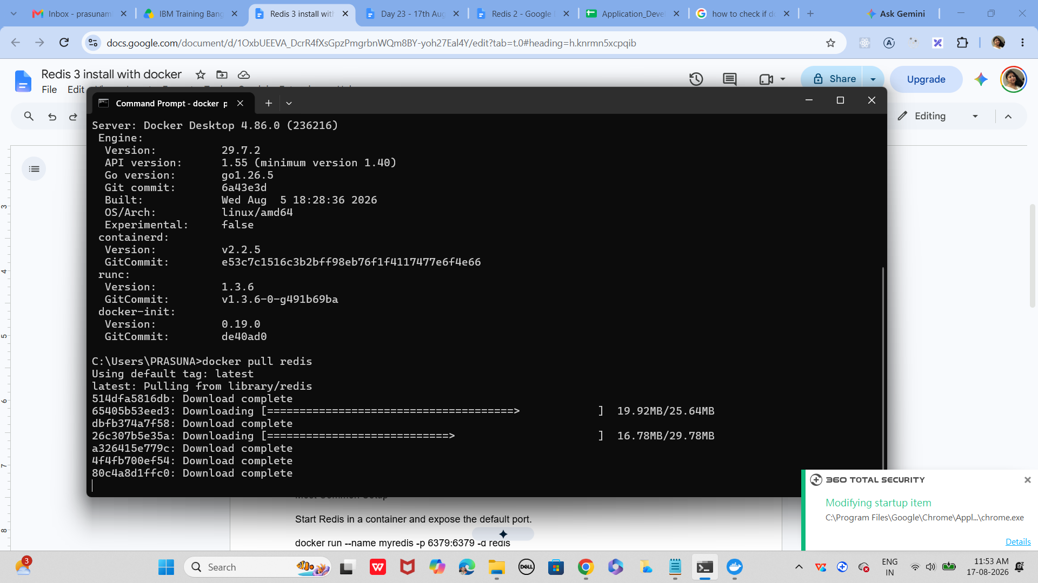
If pull is success

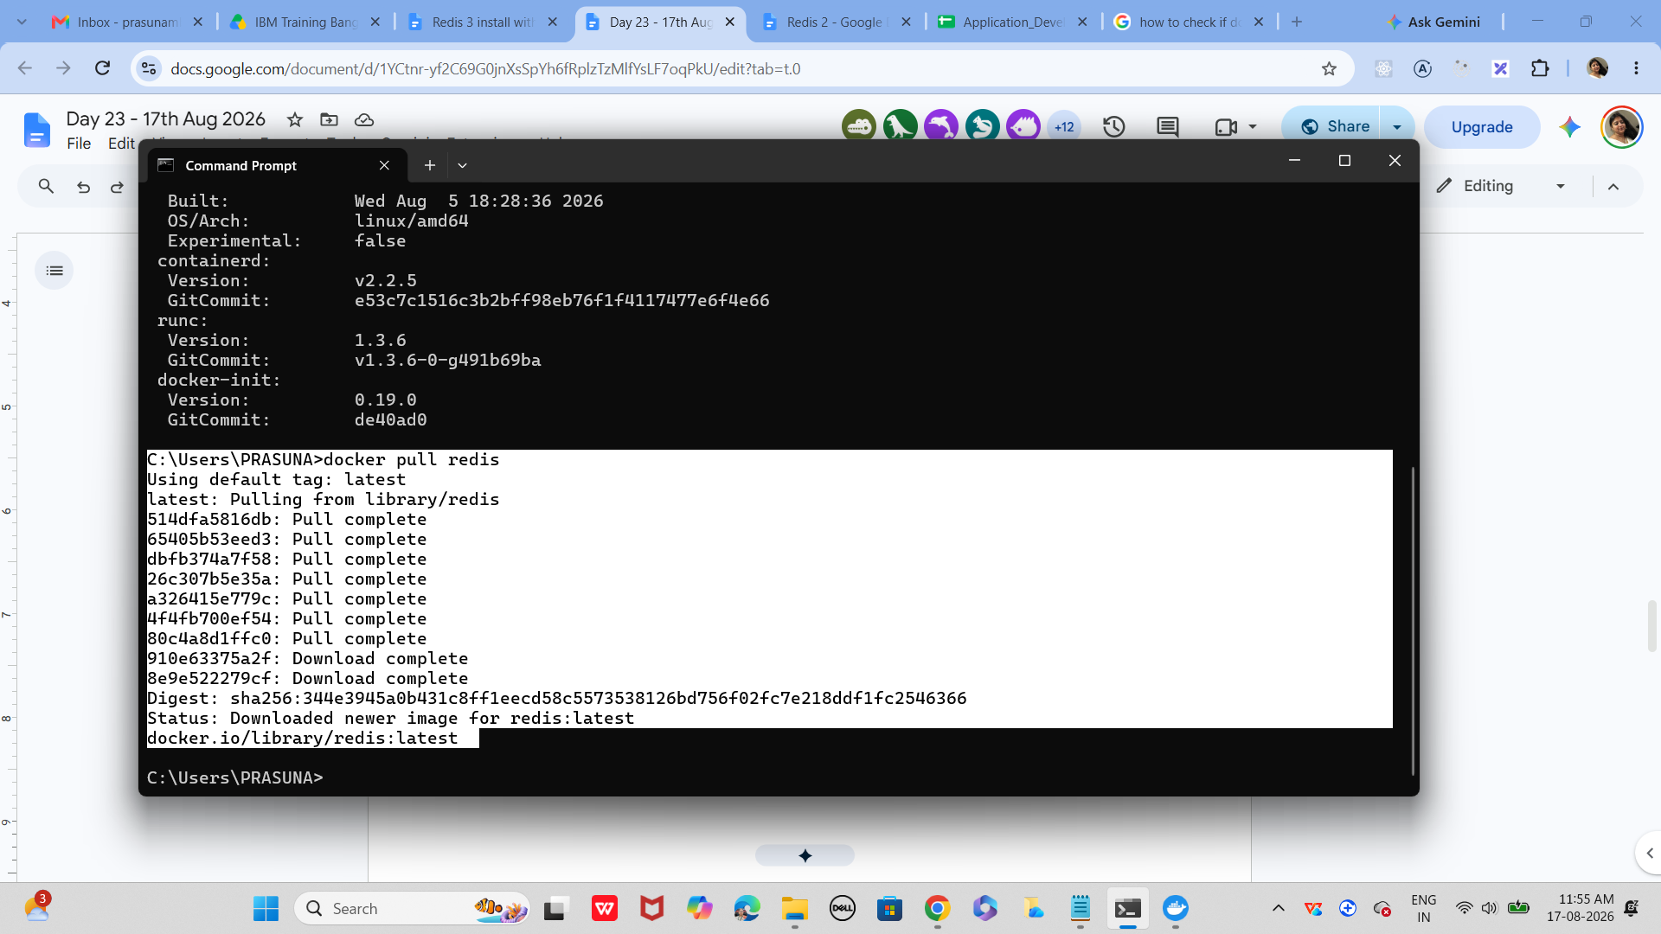

Use the command to check image

Docker images



Task 6:

Now run redis container

docker run --name myredis -p 6379:6379 -d redis
Myredis is the name of the container i m creating you can give ur own
-p 6379:6379 this will map the port no to th local host.
-d redis means we RE RUNNING IN detached mode..
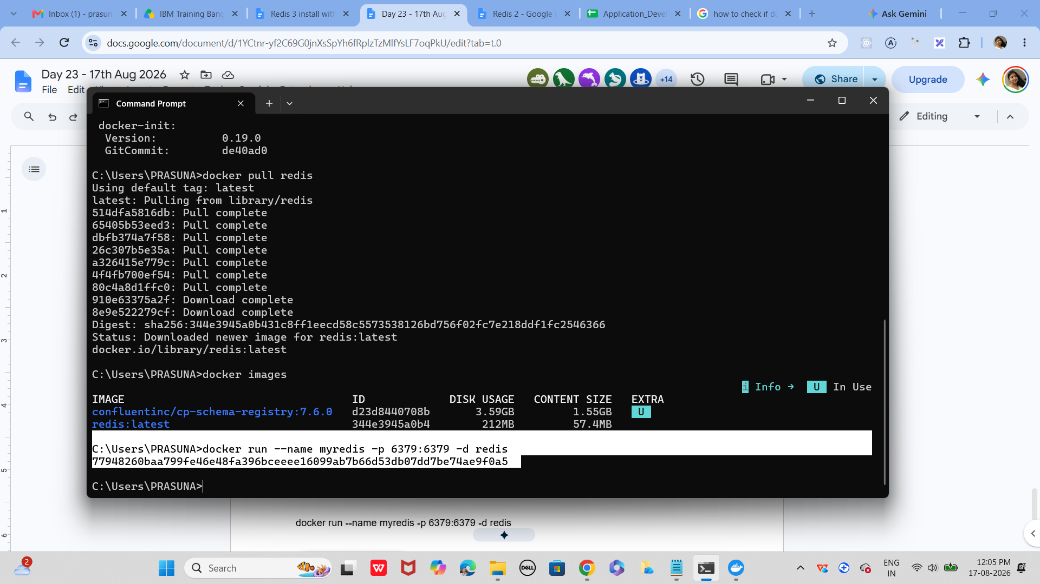
Task 7:
Now will test the connection
docker exec -it myredis redis-cli
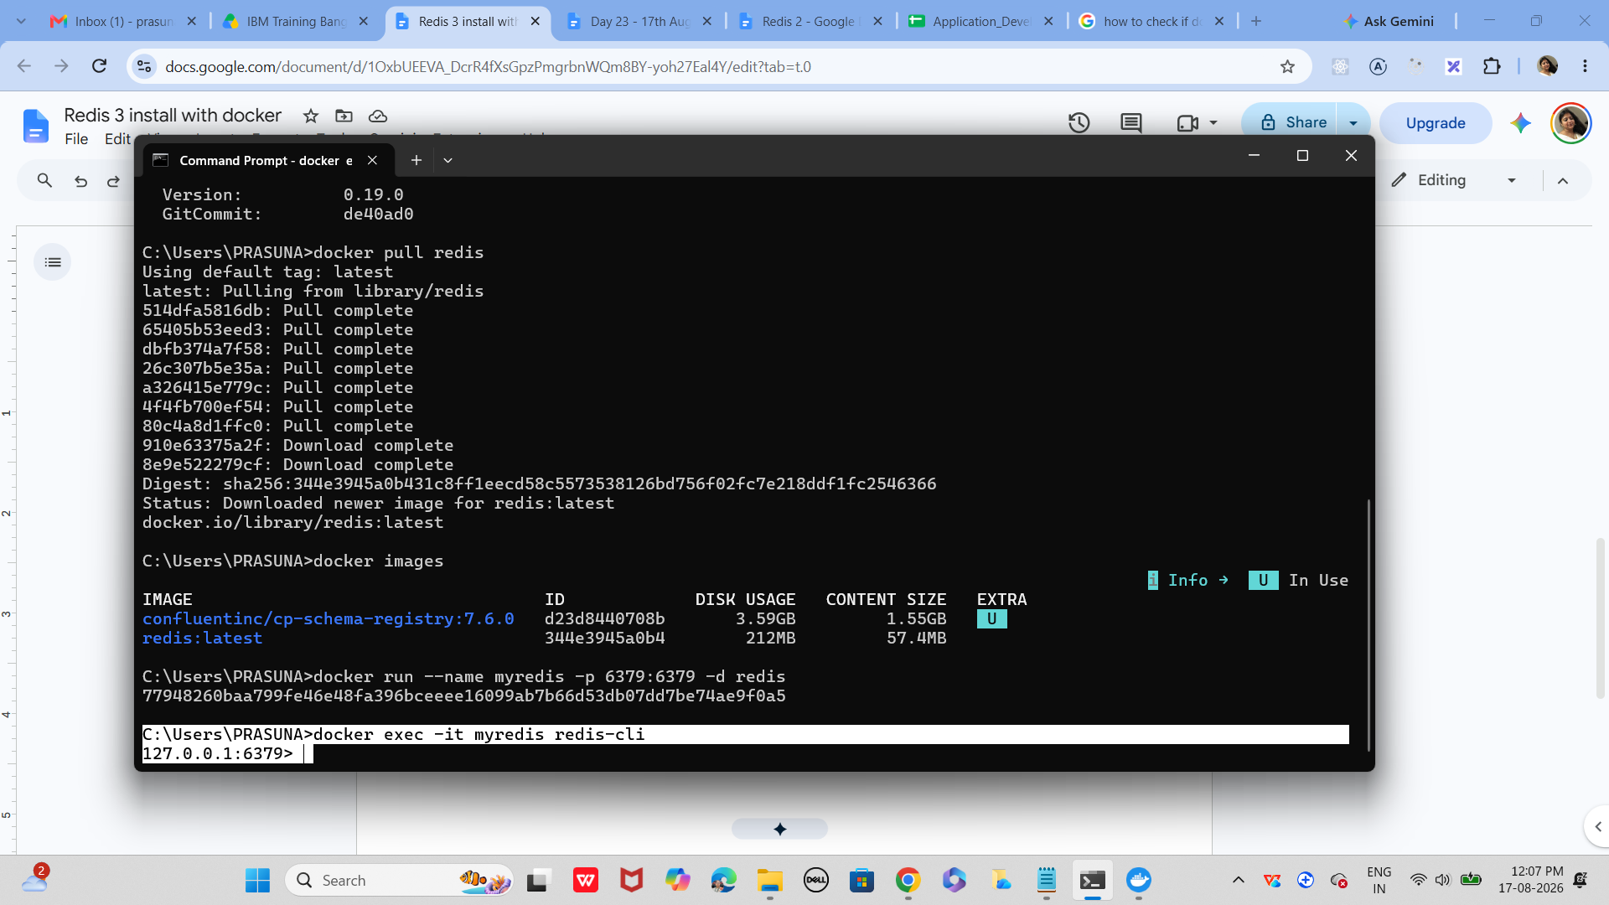

Task 8:
Type Ping
The output should be pong
Pong
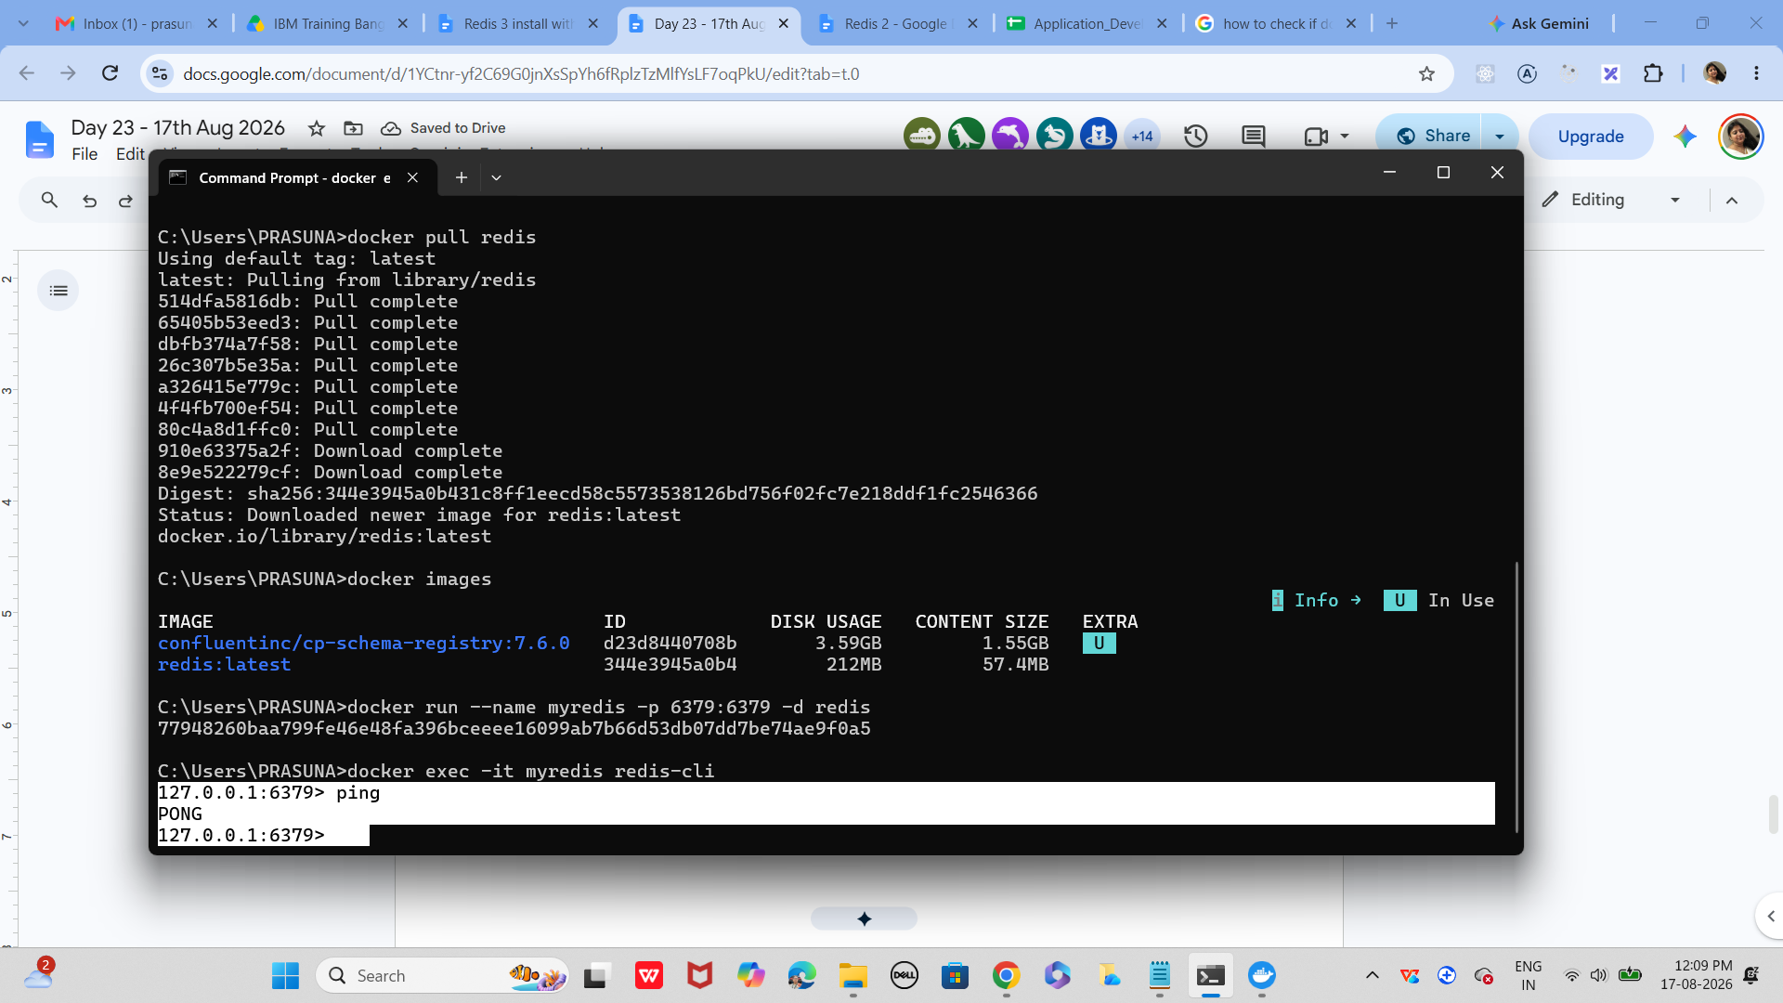

Task 9:
127.0.0.1:6379> set mykey1 "hello Prasunamba from redis"
OK
127.0.0.1:6379> get mykey1
"hello Prasunamba from redis"
127.0.0.1:6379>

Task 10:
127.0.0.1:6379> incr counter
(integer) 1
127.0.0.1:6379> get counter
"1"

Task 11:
To run hashset you need to open redis - cli
How to do that
- Use command you will see redis if its working or else it will show exit status
  - docker ps -a
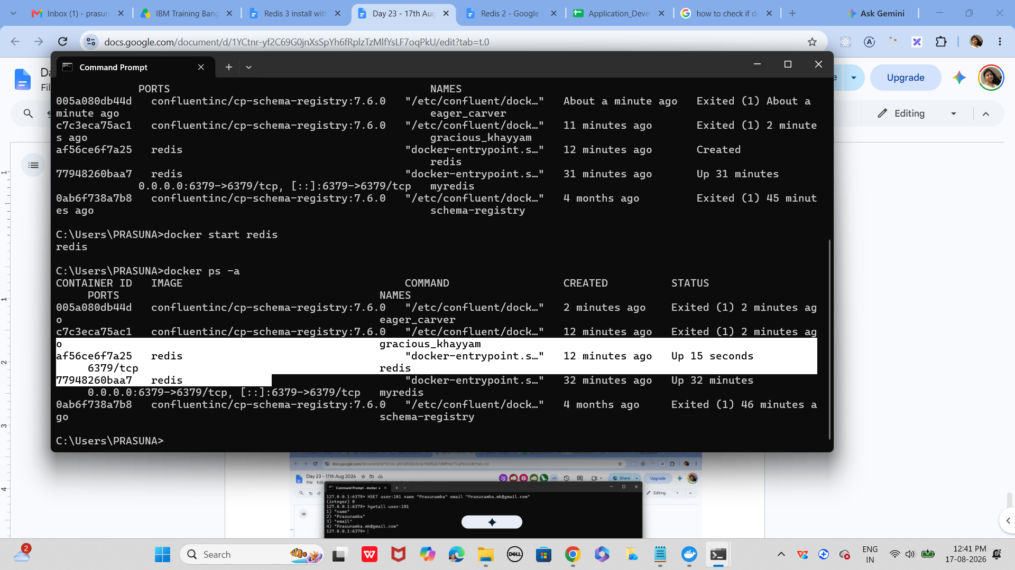

Now open another command promt
And use
HSET user:101 name "Prasunamba" email "Prasunamba.mk@gmail.com"

And get using
hgetall user:101
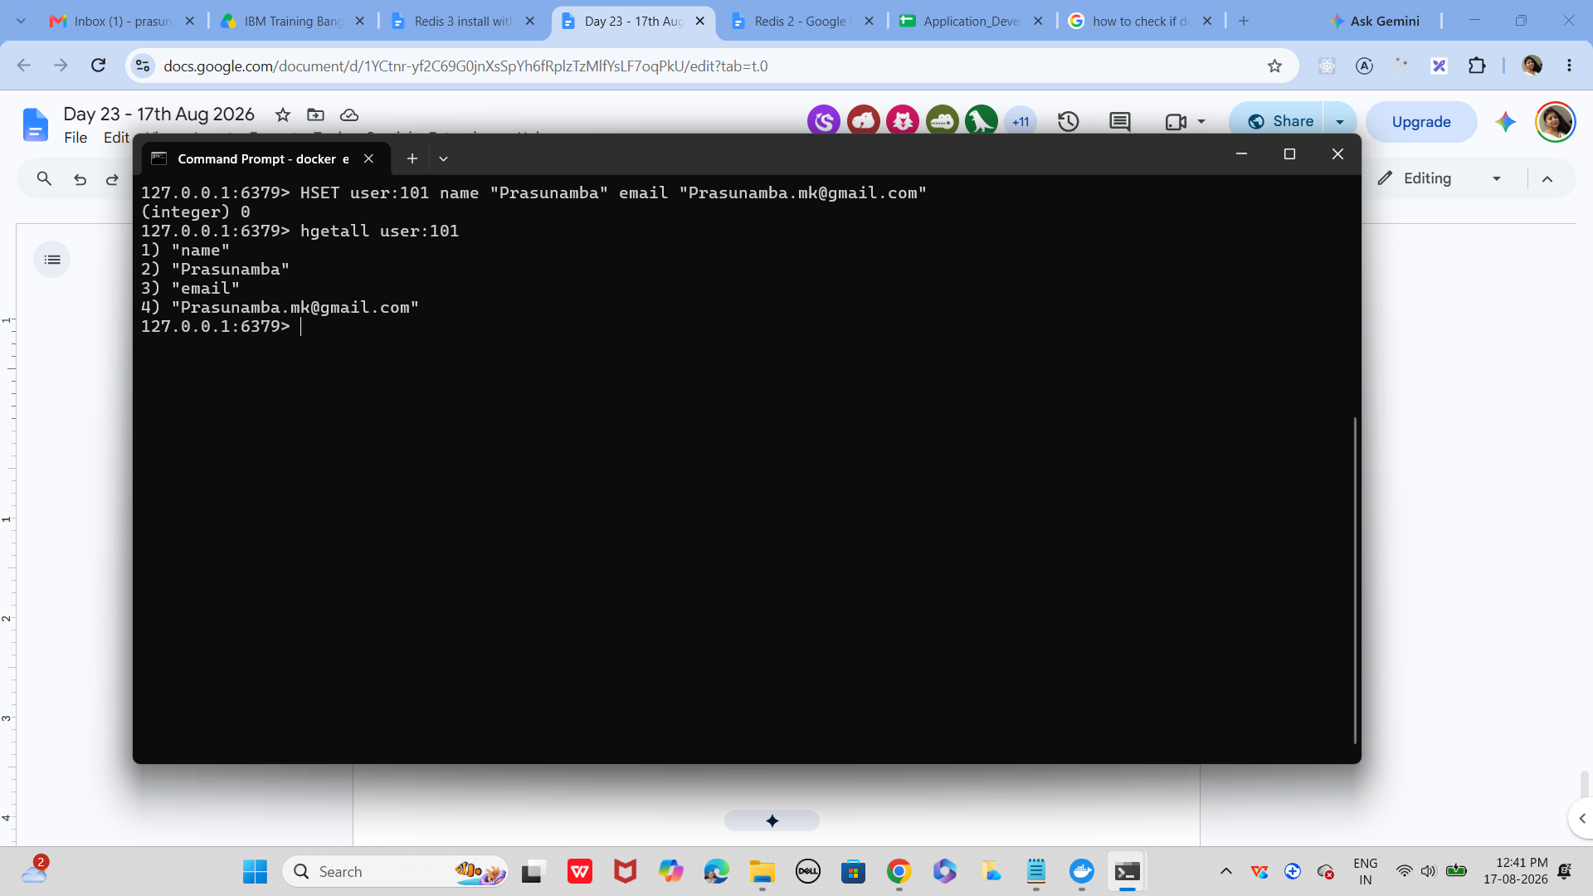

Task 12:
List of ordered collections
LPUSH tasks "Task1"
LPUSH tasks "Task2"
LRANGE tasks 0 -1
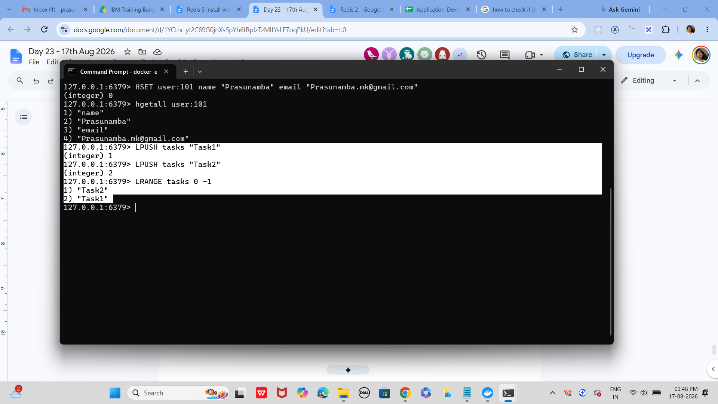
Task 13:
Sets (unique value)
SADD customrs1 "Prasunamba" "Meher" "K"
SMEMBERS customrs1
SISMEMBER customrs1 "K" (sismember is checking if the value exists or not.
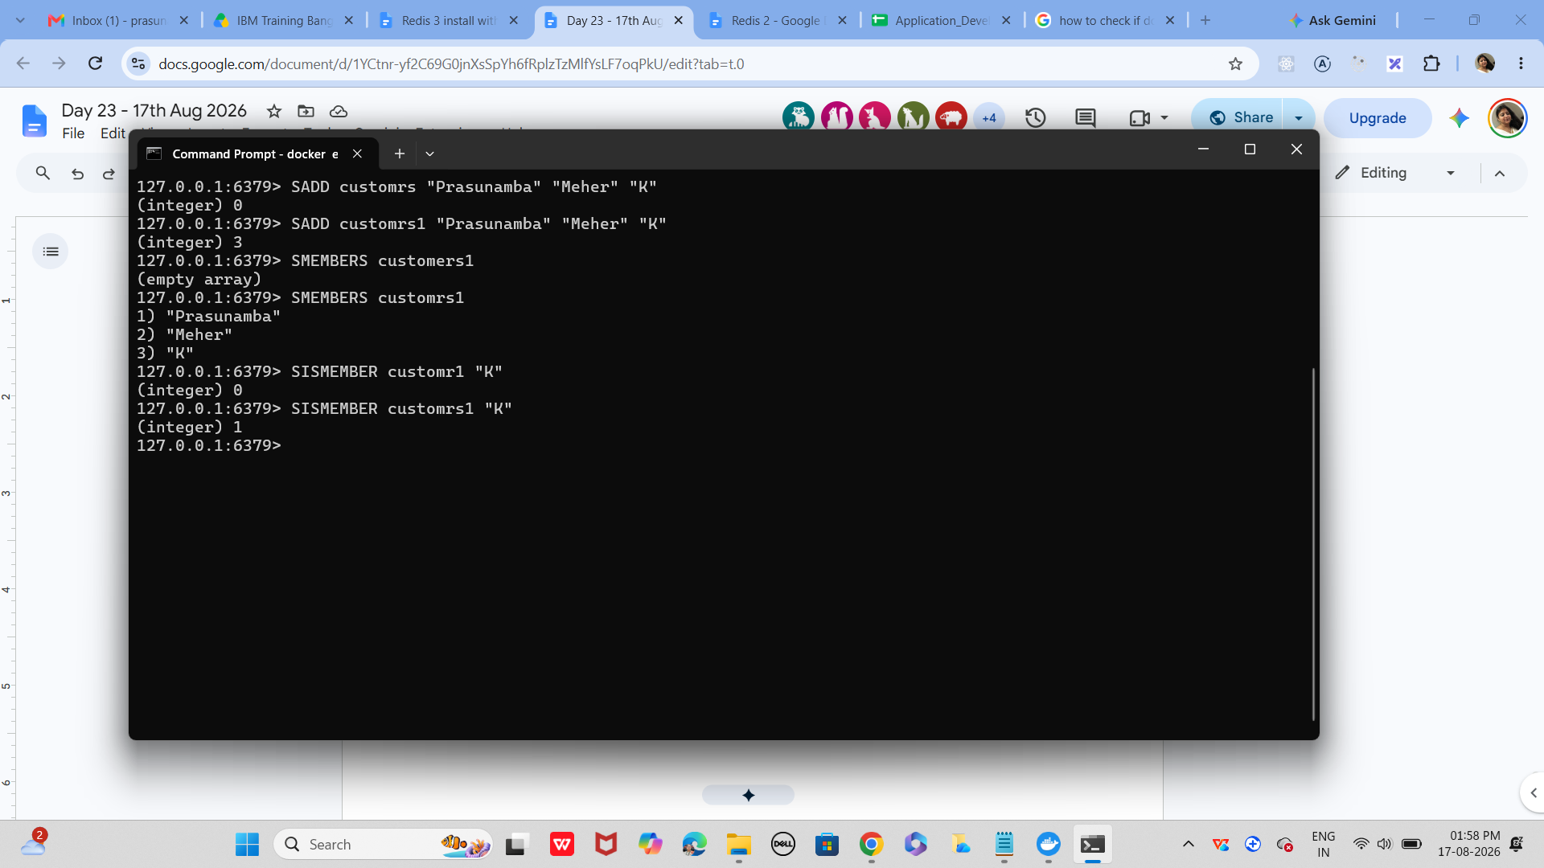

Task 14:
In the same way can you check sorted set … zsets .. what are they ?why they are used ? how to use ? cn you try ?
Like zadd leaderboard 100 “Prasunamba”

Task 15:
127.0.0.1:6379> set user:1 "Prasunamba"
OK
127.0.0.1:6379> exists user:1
(integer) 1
127.0.0.1:6379> del user:1
(integer) 1
127.0.0.1:6379> keys *
1) "user:101"
2) "customrs"
3) "user"
4) "tasks"
5) "customrs1"
127.0.0.1:6379> rename user:1 user:100
(error) ERR no such key
127.0.0.1:6379> rename user:2 user:100
(error) ERR no such key
127.0.0.1:6379> set user:1 "Prasunamba"
OK
127.0.0.1:6379> rename user:1 user:100
OK
127.0.0.1:6379> keys *
1) "user:100"
2) "user:101"
3) "customrs"
4) "user"
5) "tasks"
6) "customrs1"
127.0.0.1:6379> expire session:123 10
(integer) 0
127.0.0.1:6379> expire session:123 10 ttl session:123
(error) ERR Unsupported option ttl
127.0.0.1:6379> SET session:123 "active"
OK
127.0.0.1:6379> expire session:123 10
(integer) 1
127.0.0.1:6379> ttl session:123
(integer) -2
127.0.0.1:6379> expire session:123 1000
(integer) 0
127.0.0.1:6379> ttl session:123
(integer) -2
127.0.0.1:6379> expire session:123 1000000
(integer) 0
127.0.0.1:6379> ttl session:123
(integer) -2
127.0.0.1:6379> get session:123
(nil)
127.0.0.1:6379>

Task 16:
expire session:123 10000 // setting expiry to 10000
(integer) 1
127.0.0.1:6379> ttl session:123
(integer) 9993 // plz observe every time you check ttl it will decrease.
127.0.0.1:6379> ttl session:123
(integer) 9989 // still time to live is 9989 sec
127.0.0.1:6379> ttl session:123
(integer) 9987
127.0.0.1:6379> ttl session:123
(integer) 9985
127.0.0.1:6379> ttl session:123
(integer) 9984
127.0.0.1:6379> ttl session:123
(integer) 9983
127.0.0.1:6379> ttl session:123
(integer) 9977
127.0.0.1:6379> PERSIST session:123 // persists the data permanently in the memory and removes the expiry.
(integer) 1

Task 17:
How does Cache‑Aside balance freshness and performance, and what risks arise if the database is updated frequently?
3.30 to 3.33
Task 18:
In what type of workload would Write‑Behind caching introduce consistency challenges compared to Write‑Through?
3.34 to 3.36
Task 19:
Why might LFU eviction be more suitable than LRU eviction in recommendation systems?

Task 20:
What are the trade‑offs between time‑based invalidation and event‑based invalidation?
3.37 to 3.40
Task 21:
How would you design cache invalidation for a real‑time stock trading system?
3.41 to 3.45

Home task:

Task 22:
How does sharding in Redis clusters improve scalability, and what complexity does it add to key management?

